Hal Elrod Bio and (Suggested) Interview Questions

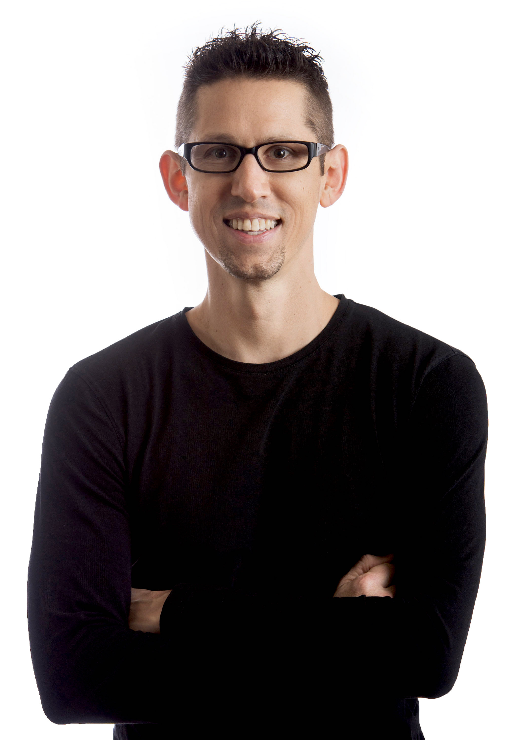
Bio/Intro
First and foremost, Hal Elrod is a family man. He is a loyal husband to his wife of 13 years, and a dedicated father to their two children.
When he’s not with his family, he is sharing his message as an author and keynote speaker. After surviving multiple near-death experiences and impacting millions of people through his books and speeches, Hal’s mission is to elevate the consciousness of humanity, one morning at a time.
As the author of 12 books, most notably, The Miracle Morning—which is translated into 37 languages and has sold over 2.5 million copies—he is doing exactly that. He’s also appeared on The Today Show, he’s been featured in SUCCESS Magazine, and written for Entrepreneur.com.
His latest project is The Miracle Morning Movie–a documentary that shows you how millions of people are transforming their lives, by simply changing how they start their day.
Today, Hal is going to show you how you can do the same.

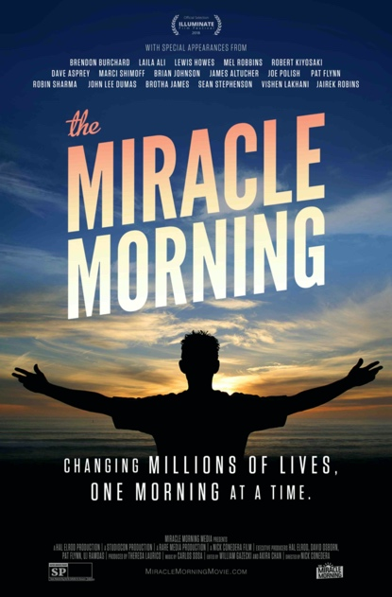
Suggested Questions (Feel free to pick, choose, customize or add your own):
- Your first near death experience took place when you were 20 years old, and you actually died for six minutes. Can you tell us what happened to you, and what are the most valuable lessons that you learned from your experiences?
- For anyone who isn’t familiar with The Miracle Morning, what is it and how can it help people to achieve everything they want in life?
- What do you say to someone who doesn’t consider themselves to be a “morning person?”
- So, you were in the middle of filming The Miracle Morning movie when you were diagnosed with a rare and aggressive form of cancer and if I’m not mistaken, you were given a 30% chance of surviving. How did you handle that experience, and how were you able to defy the odds to beat cancer and be with us today?
- As our world is in the midst of unprecedented times, and many people are experiencing unprecedented challenges, what do you believe is most important for each of us to focus on right now?
- Your mission and the mission of The Miracle Morning Community is to “elevate the consciousness of humanity, one morning at a time.” That’s pretty lofty mission. Can you expand on that?
- So, what’s the most effective way for someone to get started with the Miracle Morning?
- Is there anything else you’d like to share?

Need to contact Hal directly, before or during the interview? Text 916-459-6788.

